AI Assignment-5.1

Name: G.Nithin

HT.NO: 2403A52121

Batch: AIB04

Task 1: Use an AI tool to generate a Python program that connects to a  
weather API

Code:

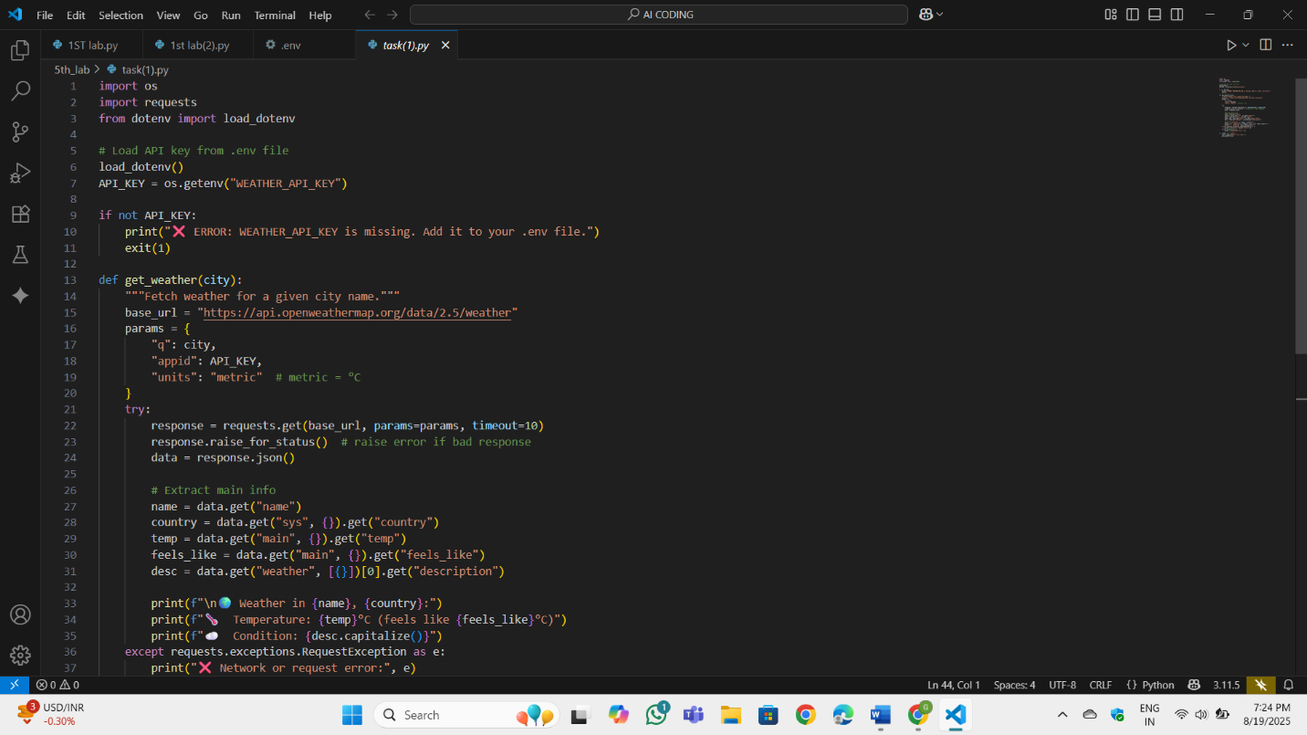

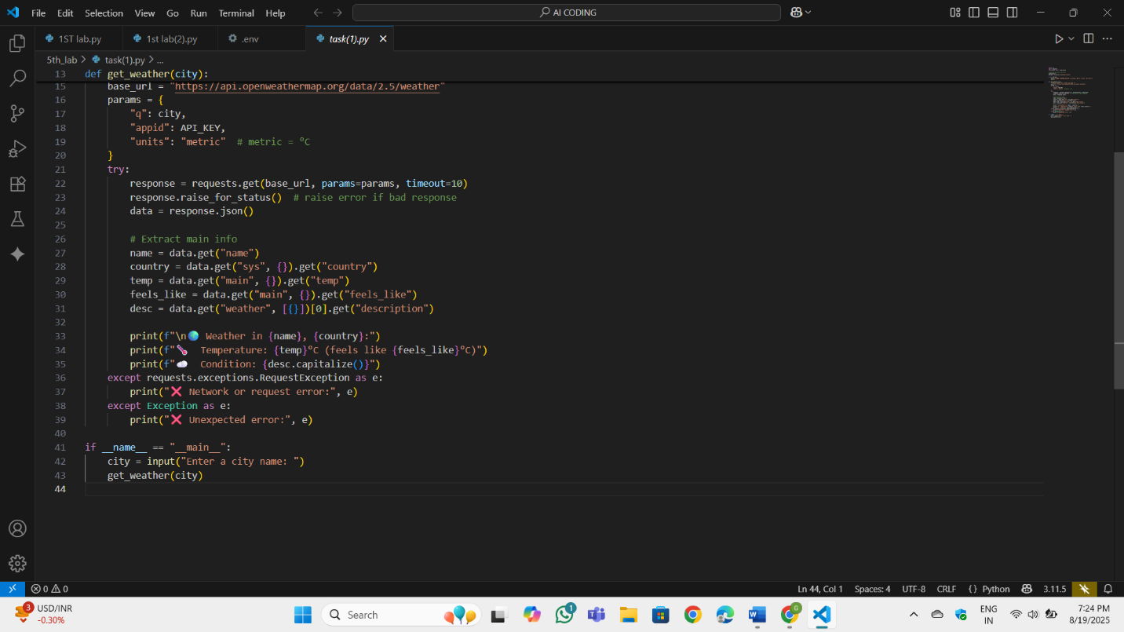



OP:

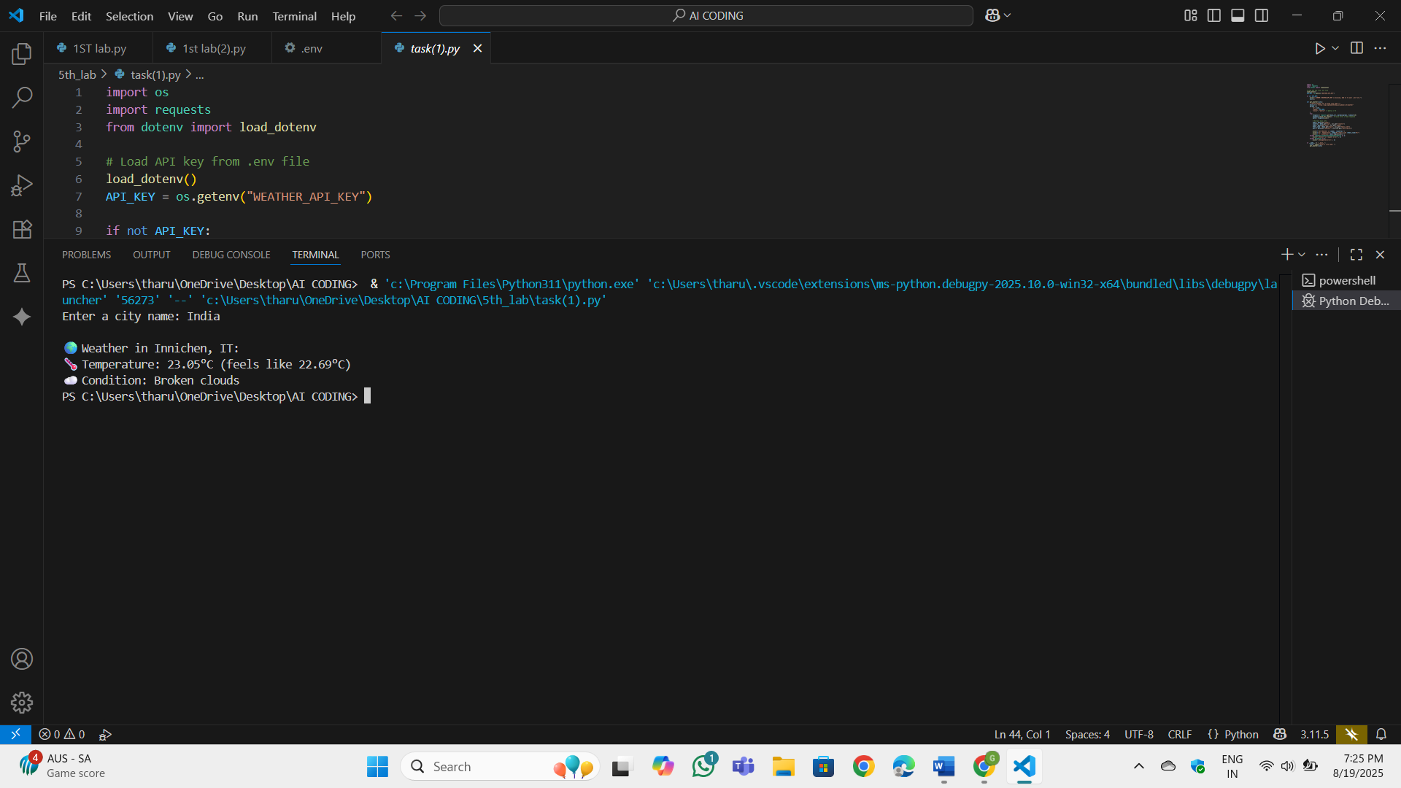

Task 2: Use an AI tool to generate a Python script that stores user data  
(name, email, password) in a file

Code:

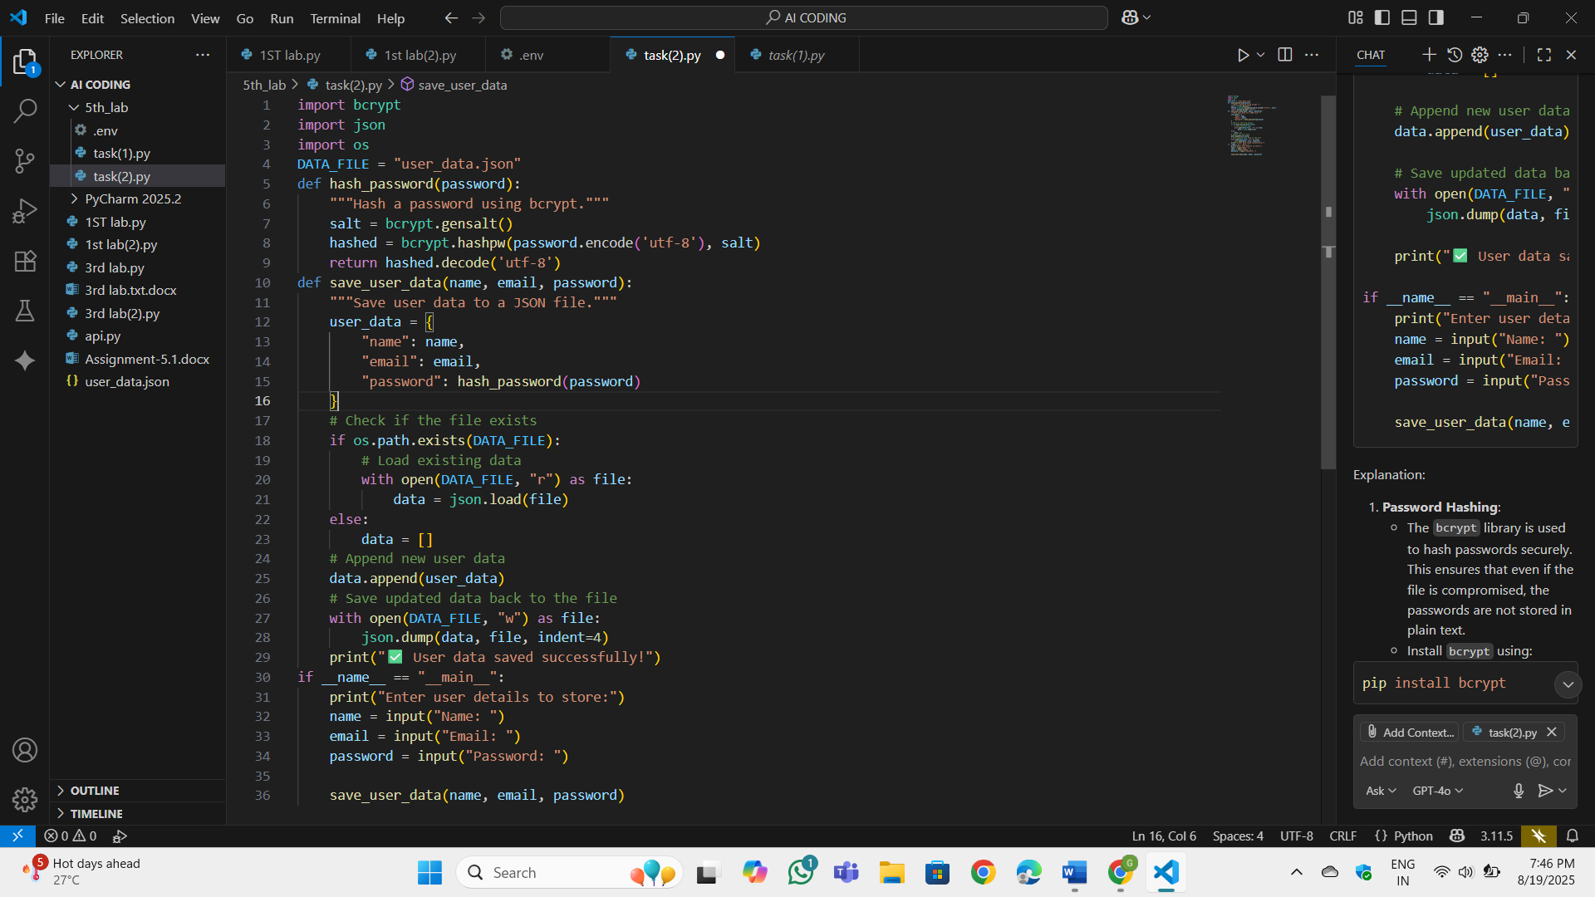

OP:

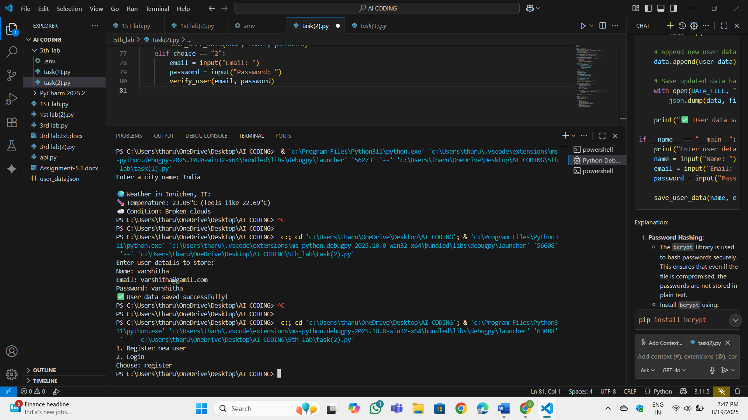

Task 3: Generate an Armstrong number checking function  
with comments and explanations.

Code:

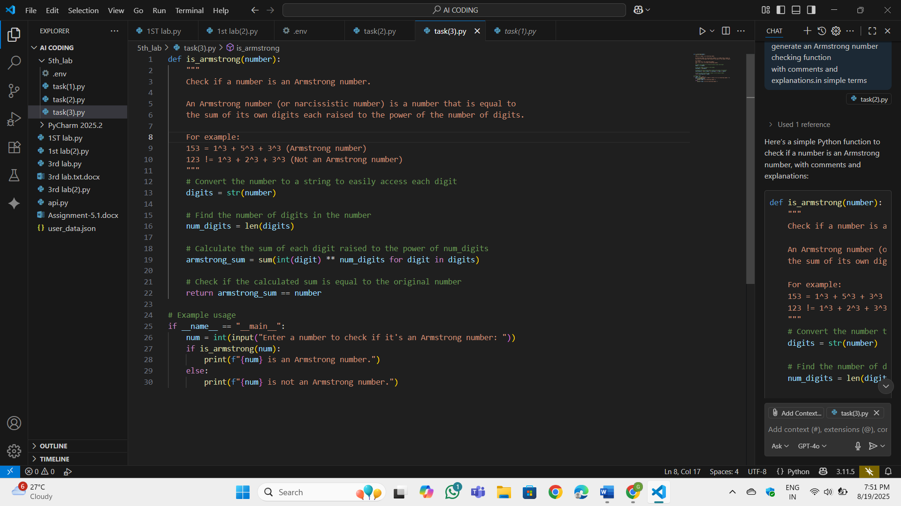

OP:

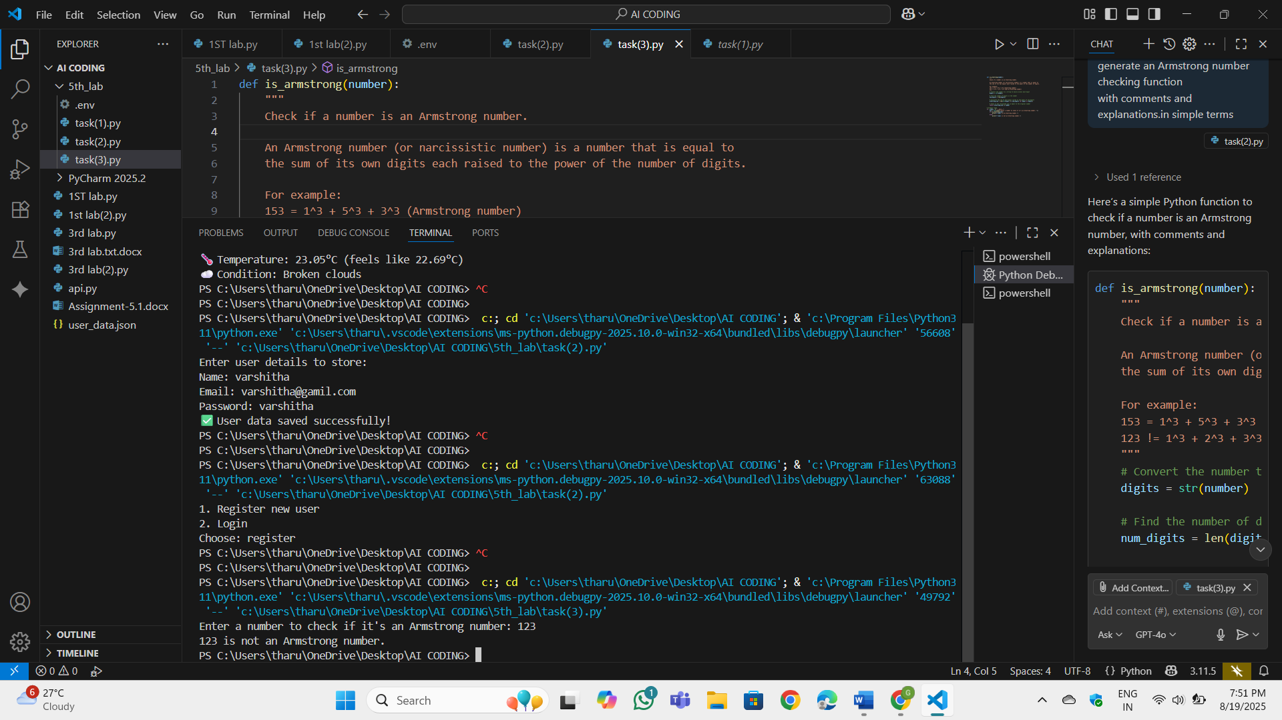

Task 4: Use AI to implement two sorting algorithms (e.g., QuickSort and  
BubbleSort).

OP:

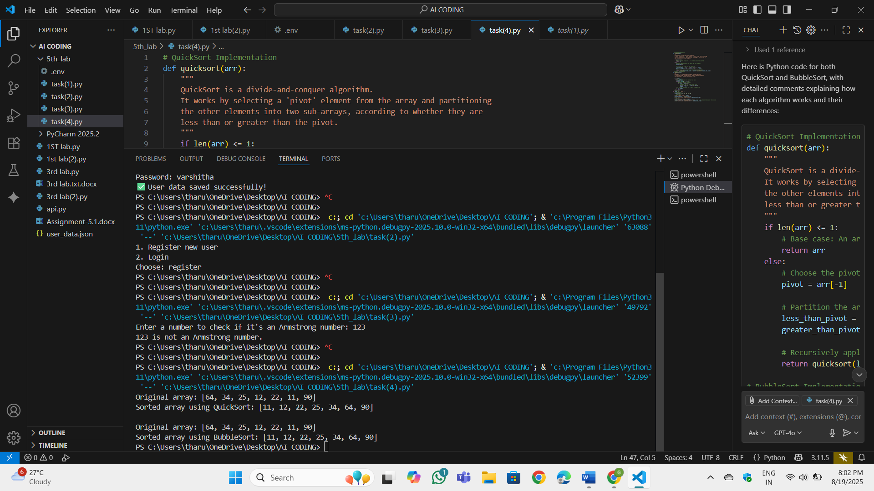

Code:

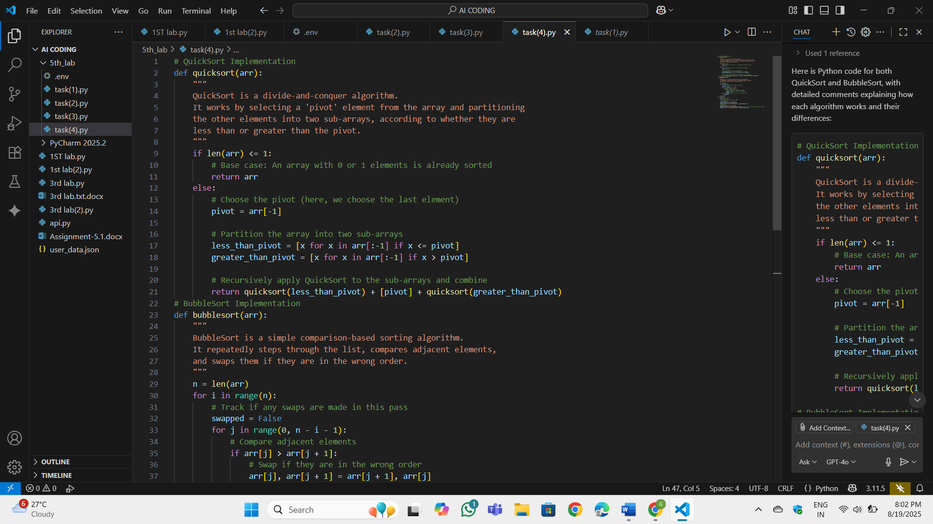

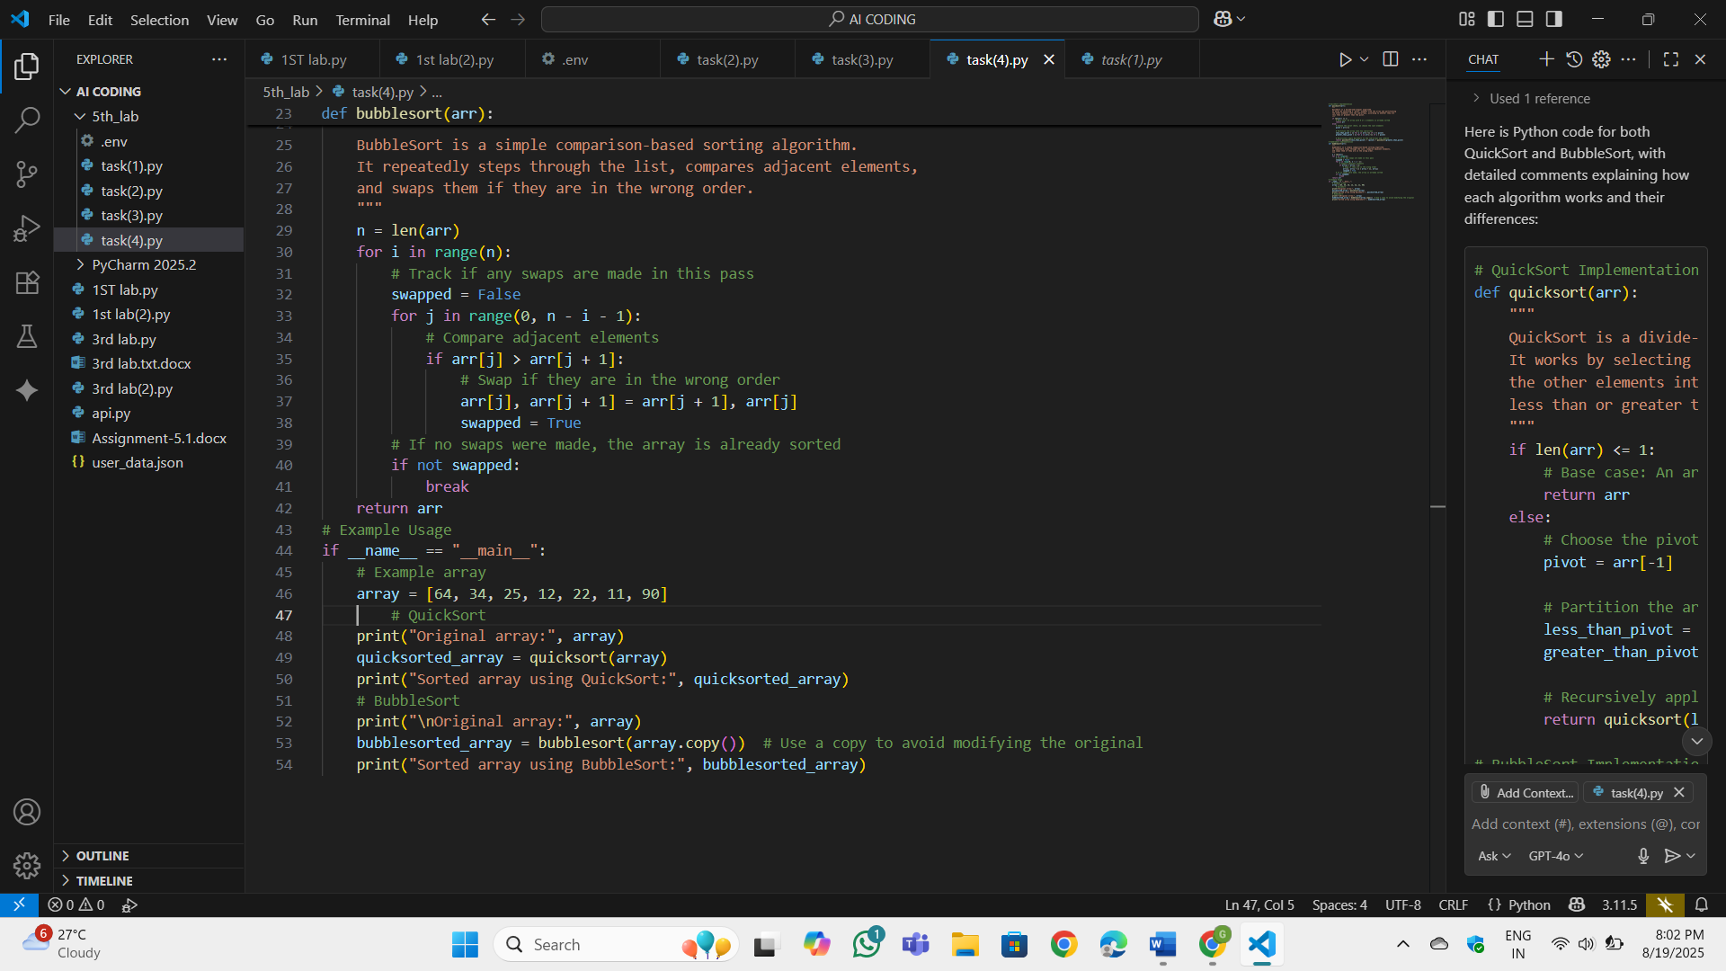

Task 5: Use AI to create a product recommendation system

Code:



OP:

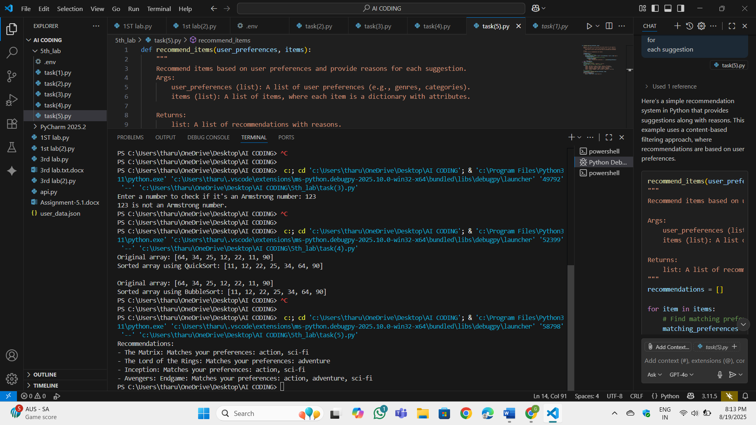

Task 6: Ask AI to generate a Python function for calculating factorial  
using recursion.

Code:

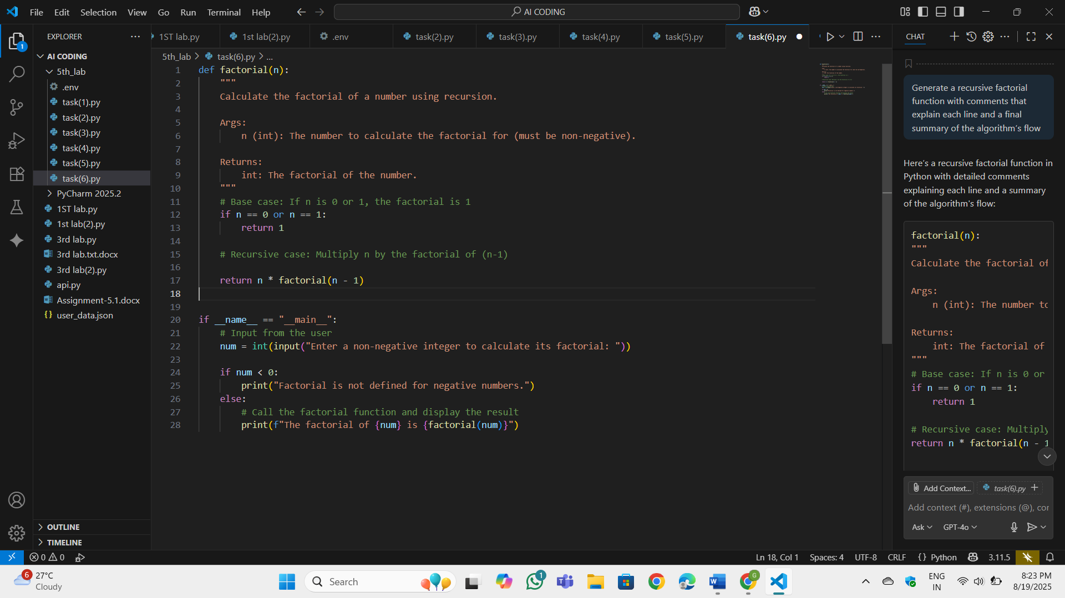

OP:

